**PSYCHROMETRIC METHOD OF A/C EQUIPMENT SELECTION**

This section shows the values that will used in Psychrometric Calculation leading to equipment selection.

**GROUND FLOOR at 24°C initial condition;**

Qs = 33188.2535 W

QL = 7296.1202 W

QT = 40484.3736 W

$\text{SHF = }\frac{{\text{Q}}_{\text{s}}}{{\text{Q}}_{\text{T}}}\text{= }\frac{\text{33188.25347 W}}{\text{40484.37363 W}}\text{ x 100\%}$

SHF = 0.8197793493 ≈ 0.82

SCHEMATIC DIAGRAM:

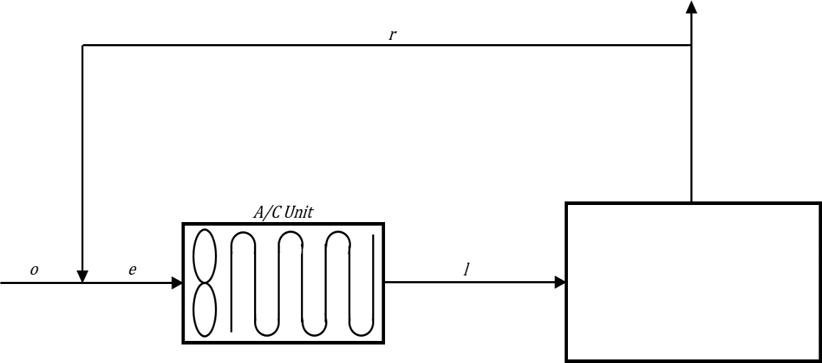

**34.5 °CDB & 26.1 °CWB**

**24 °CDB & 50% RH QS = 33188.2535 QT = 40484.3736 W**

**Figure 10.0** Schematic Diagram of Air-Conditioning System for Ground Floor at 24 °C

At outdoor condition: 34.5°CDB and 26.1°CWB

Where WO = 0.018136752

${\text{W}}_{\text{o}}\text{= }\frac{\text{0.622}{\text{P}}_{\text{S}}}{{\text{P}}_{\text{T}} \text{-}{\text{ P}}_{\text{S}}}$

$\text{0.018136752= }\frac{\text{0.622}{\text{P}}_{\text{S}}}{\text{101.325 }\text{-}{\text{ P}}_{\text{S}}}$

Solving for PS:

P­S = 2.870882826 kPa

For the computation of enthalpy;

ho = cpTo + Wohg

ho = 1.0062(34.5°C) + 0.01813675(2564.5)

ho = 81.2256005 KJ/kg

Solving for the specific volume;

vO = 0.8963812873 m3/kg

The mass flowrate from ventilation supply:

$${\text{m}}_{\text{O}}\text{ = }\frac{{\text{Q}}_{\text{Ventilation}}}{{\text{v}}_{\text{o}}}$$

$${\text{m}}_{\text{O}}\text{ = }\frac{\text{160 L/s}}{\text{896.3812873 L/kg}}$$

mo = 0.1784854709 kg/s

For the properties of return air condition;

Where wi = 0.009293235

$${\text{w}}_{\text{r}}\text{ = }\frac{{\text{0.622P}}_{\text{S}}}{{\text{P}}_{\text{T}}\text{- }{\text{P}}_{\text{S}}}$$

$${\text{w}}_{\text{r}}\text{ = }\frac{\text{0.622(0.5 x 2.982 kpa)}}{\text{101.325- (0.5 x 2.982 kpa)}}$$

wr = 0.009289440471 kg/kgm

For the computation of enthalpy;

hr = cpTr + wrhg

hr = 1.0062(24°C) + (0.009289440471 kg/kgm)(2545.5 KJ/kg)

hr = 47.79507072 KJ/kg

For the mass flowrate from sensible heat load;

${\text{Q}}_{\text{s}}\text{=}{\text{m}}_{\text{e}}\text{cp∆T}$

me = ma

Solving for ma:

ma = 3.141309923 kg/s

$\frac{{\text{m}}_{\text{o}} }{{\text{m}}_{\text{a}}}\text{= }\frac{\text{0.1784954709 kg/s}}{\text{3.141309923 kg/s}}\text{ x 100\%}$

$$\frac{m_{o}}{m_{a}}=5.682198677 \%$$

Since $\frac{m_{o}}{m_{a}}$ is less than 10% then, use 10% as the value of $\frac{m_{o}}{m_{a}}$

General equation

mowo + mrwr = mewe

.01me (0.018136752) + 0.9me (0.009289440471) = mewe

Solving for we;

we = 0.0101741716 kga/kgv

moho + mrhr = mehe

0.1me (81.2256005) + 0.9me (47.79507072) = me(he)

Solving for he;

he = 51.1381237 KJ/kg

moto + mrtr = mete

0.1me (34.5) + 0.9me (24) = me(te)

Solving for te;

Te = 25.06°C

From psychometric chart:

TL = 11.4°C

For capacity of cooling coil;

Capacity = me (he – hL)

Capacity = 3.141309923 kg/s (51.1381237 – 32.32978727 KJ/kg)

**Capacity = 59.08281386 KW**

**GROUND FLOOR AT 22°C initial condition**

Qs = 7016.44462 W

QL = 3529.72376W

QT = 10546.16838 W

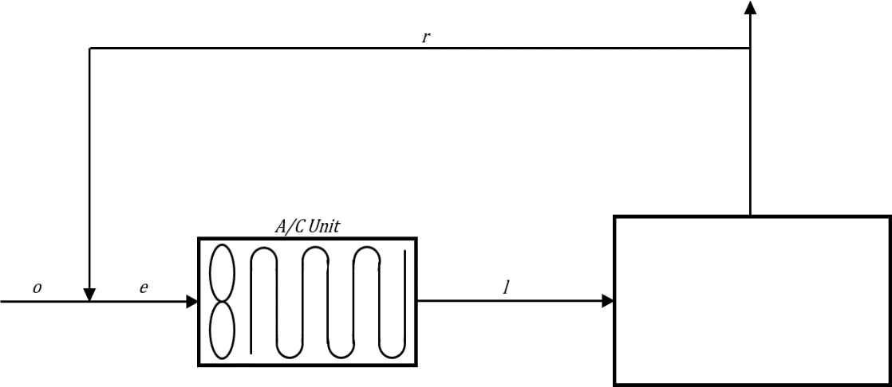 $\text{SHF = }\frac{{\text{Q}}_{\text{s}}}{{\text{Q}}_{\text{T}}}\text{= }\frac{\text{7016.44462 W}}{\text{10546.16838 W}}\text{ x 100\%}$

**34.5 °CDB & 26.1°CWB**

**22 °CDB & 50% RH QS = 7016.4446 W QT = 10546.1684 W**

SHF = 0.6653074716 ≈ 0.67

**Figure 11.0** Schematic Diagram of Air-Conditioning System for Ground Floor at 22 °C

At outdoor condition: 34.5°CDB and 26.1°CWB

Where WO = 0.018136752

${\text{W}}_{\text{o}}\text{= }\frac{\text{0.622}{\text{P}}_{\text{S}}}{{\text{P}}_{\text{T}} \text{-}{\text{ P}}_{\text{S}}}$

$\text{0.018136752= }\frac{\text{0.622}{\text{P}}_{\text{S}}}{\text{101.325 }\text{-}{\text{ P}}_{\text{S}}}$

Solving for PS:

P­S = 2.870882826 kPa

For the computation of enthalpy;

ho = cpTo + Wohg

ho = 1.0062(34.5°C) + 0.01813675(2564.5)

ho = 81.2256005 KJ/kg

Solving for the specific volume;

vO = 0.8963812873 m3/kg

The mass flowrate from ventilation supply:

$${\text{m}}_{\text{O}}\text{ = }\frac{{\text{Q}}_{\text{Ventilation}}}{{\text{v}}_{\text{o}}}$$

$${\text{m}}_{\text{O}}\text{ = }\frac{\text{85 L/s}}{\text{896.3812873 L/kg}}$$

mo = 0.09482571893 kg/s

For the properties of return air condition;

Where wi = 0.00821976 kga/kgv

wi = wr

For the computation of enthalpy;

hr = cpTr + wrhg

hr = 1.0062(22°C) + (0.00821976 kg/kgm)(2541.8 KJ/kg)

hr = 43.02938597 KJ/kg

For the mass flowrate from sensible heat load;

${\text{Q}}_{\text{s}}\text{=}{\text{m}}_{\text{e}}\text{cp∆T}$

me = ma

Solving for ma:

ma = 0.5578568571 kg/s

$\frac{{\text{m}}_{\text{o}} }{{\text{m}}_{\text{a}}}\text{= }\frac{\text{0.09482571893 kg/s}}{\text{0.5578568571 kg/s}}\text{ x 100\%}$

$$\frac{m_{o}}{m_{a}}=16.99821697 \%$$

General equation

mowo + mrwr = mewe

0.1699821697me (0.018136752) + 0.8300178303me (0.00821976) = mewe

Solving for we;

we = 0.009944698262 kga/kgv

moho + mrhr = mehe

0.1699821697me (81.2256005) + 0.8300178303me (43.02938597) = me(he)

Solving for he;

he = 49.52206139 KJ/kg

moto + mrtr = mete

0.1699821697me (34.5) + 0.8300178303me (22) = me(te)

Solving for te;

Te = 24.12477712°C

From psychometric chart:

TL = 5.1°C

Solving for hL;

hL = 17.4701059 KJ/kg

For capacity of cooling coil;

Capacity = me (he – hL)

Capacity = 0.5578568571 kg/s (49.52206139 KJ/kg – 17.4701059 KJ/kg)

**Capacity = 17.88040315 KW**

**GROUND FLOOR AT 22.5°C initial condition**

Qs = 60346.52683 W

QL = 22546.97898W

QT = 82893.50581 W

$\text{SHF = }\frac{{\text{Q}}_{\text{s}}}{{\text{Q}}_{\text{T}}}\text{= }\frac{60346.52683 \text{ W}}{82893.50581\text{ W}}\text{ x 100\%}$

SHF = 0.728006587 ≈ 0.73

SCHEMATIC DIAGRAM:

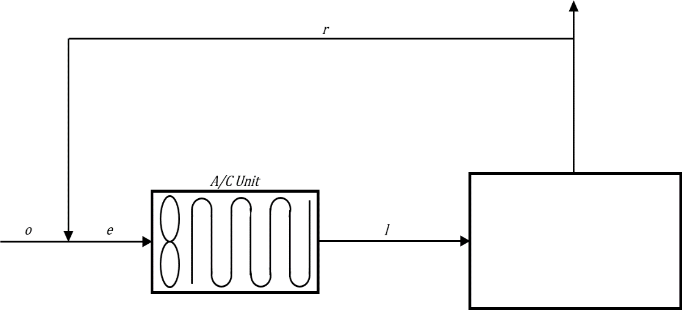

**33.9 °CDB & 26.7 °CWB**

**22.5°CDB & 50% RH QS = 60346.5268 W QT = 82893.5058 W**

**Figure 12.0** Schematic Diagram of Air-Conditioning System for Ground Floor at 22 °C

At outdoor condition: 34.5°CDB and 21.6°CWB

Where WO = 0.018136752

${\text{W}}_{\text{o}}\text{= }\frac{\text{0.622}{\text{P}}_{\text{S}}}{{\text{P}}_{\text{T}} \text{-}{\text{ P}}_{\text{S}}}$

$\text{0.018136752= }\frac{\text{0.622}{\text{P}}_{\text{S}}}{\text{101.325 }\text{-}{\text{ P}}_{\text{S}}}$

Solving for PS:

P­S = 2.870882826 kPa

For the computation of enthalpy;

ho = cpTo + Wohg

ho = 1.0062(34.5°C) + 0.01813675(2564.5)

ho = 81.2256005 KJ/kg

Solving for the specific volume;

vO = 0.8963812873 m3/kg

The mass flowrate from ventilation supply:

$${\text{m}}_{\text{O}}\text{ = }\frac{{\text{Q}}_{\text{Ventilation}}}{{\text{v}}_{\text{o}}}$$

$${\text{m}}_{\text{O}}\text{ = }\frac{\text{398 L/s}}{\text{896.3812873 L/kg}}$$

mo = 0.4440074839 kg/s

For the properties of return air condition;

Where wi = 0.00848061 kga/kgv

wi = wr

For the computation of enthalpy;

hr = cpTr + wrhg

hr = 1.0062(22°C) + (0.00821976 kg/kgm)(2542.725 KJ/kg)

hr = 44.20335906 KJ/kg

For the mass flowrate from sensible heat load;

${\text{Q}}_{\text{s}}\text{=}{\text{m}}_{\text{e}}\text{cp∆T}$

me = ma

Solving for ma:

ma = 4.997890316 kg/s

$\frac{{\text{m}}_{\text{o}} }{{\text{m}}_{\text{a}}}\text{= }\frac{0.4440074839\text{kg/s}}{4.997890316\text{ kg/s}}\text{ x 100\%}$

$$\frac{m_{o}}{m_{a}}=8.883898122 \%$$

Since $\frac{m_{o}}{m_{a}}$ is less than 10%, then use 10% as the value of $\frac{m_{o}}{m_{a}}$

General equation

mowo + mrwr = mewe

0.1me (0.018136752) + 0.9 me (0.00848061) = mewe

Solving for we;

we = 0.0094462242 kga/kgv

moho + mrhr = mehe

0.1me (81.2256005) + 0.9 me (44.20335906) = me(he)

Solving for he;

he = 47.9055832 KJ/kg

moto + mrtr = mete

0.1me (34.5) + 0.9 me (22.5) = me(te)

Solving for te;

Te = 23.7°C

From psychometric chart:

TL = 11.8°C

Solving for hL;

hL = 29.4145643 KJ/kg

For capacity of cooling coil;

Capacity = me (he – hL)

Capacity = 4.997890316 kg/s (47.9055832 KJ/kg – 29.4145643 KJ/kg)

**Capacity = 92.41608429 kW**

**Table 43** Summary of TOR Capacity for Ground Floor

|  |  |  |  |  |  |  |  |
| --- | --- | --- | --- | --- | --- | --- | --- |
| **Space** | | **Area** | | **A/C Capacity** | **KW** | | **TOR** |
| **24°C** | | | | | | | |
| Canteen | | 181.6992 | | 59.0828 | 40.8476 | | 11.6153 |
| Storage Room | | 7.8175 | | 59.0828 | 1.7574 | | 0.4997 |
| Equipment and supply storage area | | 5.61 | | 59.0828 | 1.2612 | | 0.3586 |
| Film File storage | | 5.5203 | | 59.0828 | 1.2410 | | 0.3529 |
| Linen storage | | 8.3137 | | 59.0828 | 1.8690 | | 0.5315 |
| Cooking Area | | 34.2152 | | 59.0828 | 7.6919 | | 2.1872 |
| Cadaver Holding room | | 19.6378 | | 59.0828 | 4.4147 | | 1.2554 |
| **22°C** | | | | | | | |
| Minor Operating Room | 23.3886 | | 17.8804 | | 7.4348 | | 2.1141 |
| Work Area (Laboratory) | 32.86 | | 17.8804 | | 10.4456 | | 2.9703 |
| **22.5°C** | | | | | | | |
| Maintenance Office | 16.3095 | | 92.4161 | | 2.2765 | 0.6392 | |
| Examination / Treatment Area | 131.3000 | | 92.4161 | | 18.3274 | 5.1457 | |
| Supply Room | 31.2893 | | 92.4161 | | 4.3675 | 1.2262 | |
| Pharmacy | 20.7487 | | 92.4161 | | 2.8962 | 0.8131 | |
| Medical Records Office | 17.9512 | | 92.4161 | | 2.5057 | 0.7035 | |
| PHILHEALTH | 17.1378 | | 92.4161 | | 2.3922 | 0.6716 | |
| Doctor's Duty | 11.6062 | | 92.4161 | | 1.6200 | 0.4549 | |
| OPD Clinic Dental 1 | 14.3811 | | 92.4161 | | 2.0074 | 0.5636 | |
| OPD Clinic Dental 2 | 14.3811 | | 92.4161 | | 2.0074 | 0.5636 | |
| OPD Clinic Surgery 1 | 14.4356 | | 92.4161 | | 2.0150 | 0.5657 | |
| OPD Clinic Surgery 2 | 14.4356 | | 92.4161 | | 2.0150 | 0.5657 | |
| Cashier | 5.4875 | | 92.4161 | | 0.7660 | 0.2151 | |
| Billing | 5.5100 | | 92.4161 | | 0.7691 | 0.2159 | |
| Admitting | 5.6363 | | 92.4161 | | 0.7867 | 0.2209 | |
| Radiologist Office | 9.1492 | | 92.4161 | | 1.2771 | 0.3586 | |
| Dark Room | 4.9522 | | 92.4161 | | 0.6912 | 0.1941 | |
| Control Booth | 25.2538 | | 92.4161 | | 3.5250 | 0.9897 | |
| OPD Clinic Pedia 1 | 14.3811 | | 92.4161 | | 2.0074 | 0.5636 | |
| OPD Clinic Pedia 2 | 14.3811 | | 92.4161 | | 2.0074 | 0.5636 | |
| OPD Info. And Admitting | 9.9805 | | 92.4161 | | 1.3931 | 0.3911 | |
| OPD Clinic Medical 1 | 14.4356 | | 92.4161 | | 2.0150 | 0.5657 | |
| OPD Clinic Medical 2 | 14.4356 | | 92.4161 | | 2.0150 | 0.5657 | |
| Admin Office | 13.6070 | | 92.4161 | | 1.8993 | 0.5333 | |
| Administrative Office | 35.3177 | | 92.4161 | | 4.9298 | 1.3841 | |
| Social Welfare | 13.5984 | | 92.4161 | | 1.8981 | 0.5329 | |
| OPD Info. And Admitting | 10.4417 | | 92.4161 | | 1.4575 | 0.4092 | |
| OPD Records | 11.5919 | | 92.4161 | | 1.6180 | 0.4543 | |
| Ultrasound | 19.0769 | | 92.4161 | | 2.6628 | 0.7476 | |
| Supply Receiving Area | 5.7184 | | 92.4161 | | 0.7982 | 0.2241 | |
| Dietician's Office | 9.2250 | | 92.4161 | | 1.2877 | 0.3615 | |
| Dietary | 38.0325 | | 92.4161 | | 5.3087 | 1.4905 | |
| Staff Dining | 50.8881 | | 92.4161 | | 7.1032 | 1.9943 | |
| OPD Clinic OB-Gyne | 27.0056 | | 92.4161 | | 3.7695 | 1.0584 | |

**Table 44** Summary of TOR Capacity for Second Floor

|  |  |  |  |  |  |  |  |  |  |  |  |  |
| --- | --- | --- | --- | --- | --- | --- | --- | --- | --- | --- | --- | --- |
| **Space** | | **Area** | | | **A/C Capacity** | | | | **KW** | | | **TOR** |
| **24°C** | | | | | | | | | | | | |
| Dirty Utility | | 4.7869 | | | 26.0704 | | | | 1.9357 | | | 0.5435 |
| Clean Linen | | 2.4581 | | | 26.0704 | | | | 0.9940 | | | 0.2791 |
| Sub-Ster Room 1 | | 5.4111 | | | 26.0704 | | | | 2.1881 | | | 0.6144 |
| Sterile Supply Room | | 21.6006 | | | 26.0704 | | | | 8.7348 | | | 2.4524 |
| Sub-Ster Room 2 | | 5.6912 | | | 26.0704 | | | | 2.3014 | | | 0.6462 |
| Jan.Clo. | | 4.1338 | | | 26.0704 | | | | 1.6716 | | | 0.4693 |
| Clean Up room | | 12.9100 | | | 26.0704 | | | | 5.2205 | | | 1.4657 |
| Sterile Instrument Supply Storage Area | | 7.4784 | | | 26.0704 | | | | 3.0241 | | | 0.8491 |
| Anesthesia Office & Storage | | 17.5207 | | | 26.0704 | | | | 7.0850 | | | 1.9892 |
| **22°C** | | | | | | | | | | | | |
| Delivery Room | | | 34.9862 | | | 38.1972 | | 15.0105 | | | 4.2684 | |
| Pre-Operation Area | | | 19.0007 | | | 38.1972 | | 8.1521 | | | 2.3181 | |
| Major Operating Room | | | 35.0425 | | | 38.1972 | | 15.0347 | | | 4.2752 | |
| **22.5°C** | | | | | | | | | | | | |
| 5 Bed Ward 1 | 34.2769 | | | 160.1532 | | | 7.4910 | | | 2.1301 | | |
| 5-Bed Ward 2 | 34.2600 | | | 160.1532 | | | 7.4873 | | | 2.1291 | | |
| 5-Bed Ward 3 | 34.2900 | | | 160.1532 | | | 7.4939 | | | 2.1309 | | |
| 5-Bed Ward 4 | 34.1175 | | | 160.1532 | | | 7.4562 | | | 2.1202 | | |
| Isolation Room 1 | 13.6738 | | | 160.1532 | | | 2.9883 | | | 0.8498 | | |
| Private Room 1 | 13.9206 | | | 160.1532 | | | 3.0423 | | | 0.8651 | | |
| Private Room 2 | 13.8754 | | | 160.1532 | | | 3.0324 | | | 0.8623 | | |
| Chief Nurse | 30.7120 | | | 160.1532 | | | 6.7119 | | | 1.9086 | | |
| Treatment Room | 17.9413 | | | 160.1532 | | | 3.9210 | | | 1.1150 | | |
| Private Room 3 | 13.8735 | | | 160.1532 | | | 3.0320 | | | 0.8622 | | |
| Private Room 4 | 13.8928 | | | 160.1532 | | | 3.0362 | | | 0.8634 | | |
| Isolation Room 2 | 13.7066 | | | 160.1532 | | | 2.9955 | | | 0.8518 | | |
| Reception | 11.0522 | | | 160.1532 | | | 2.4154 | | | 0.6868 | | |
| Private Room 5 | 13.6813 | | | 160.1532 | | | 2.9900 | | | 0.8502 | | |
| Chief of Hospital | 18.7319 | | | 160.1532 | | | 4.0938 | | | 1.1641 | | |
| 3-Bed Ward 1 | 25.3720 | | | 160.1532 | | | 5.5449 | | | 1.5767 | | |
| 3-Bed Ward 2 | 25.4800 | | | 160.1532 | | | 5.5685 | | | 1.5835 | | |
| Private Room 6 | 13.7512 | | | 160.1532 | | | 3.0053 | | | 0.8546 | | |
| Conference Room | 38.4537 | | | 160.1532 | | | 8.4039 | | | 2.3897 | | |
| 3-Bed Ward 3 | 25.3720 | | | 160.1532 | | | 5.5449 | | | 1.5767 | | |
| 3-Bed Ward 4 | 25.4800 | | | 160.1532 | | | 5.5685 | | | 1.5835 | | |
| Private Room 7 | 13.7512 | | | 160.1532 | | | 3.0053 | | | 0.8546 | | |
| Private Room 8 | 13.7512 | | | 160.1532 | | | 3.0053 | | | 0.8546 | | |
| Chief of Clinics | 21.3616 | | | 160.1532 | | | 4.6685 | | | 1.3275 | | |
| Labor Room | 25.7486 | | | 160.1532 | | | 5.6272 | | | 1.6001 | | |
| Pathologic Nursery | 16.7994 | | | 160.1532 | | | 3.6714 | | | 1.0440 | | |
| Pre-mature nursery | 16.7999 | | | 160.1532 | | | 3.6715 | | | 1.0440 | | |
| Breastfeeding room | 10.2258 | | | 160.1532 | | | 2.2348 | | | 0.6355 | | |
| Autoclave area | 14.9875 | | | 160.1532 | | | 3.2754 | | | 0.9314 | | |
| Lounge Area | 41.3021 | | | 160.1532 | | | 9.0264 | | | 2.5667 | | |
| Recovery Room | 46.9742 | | | 160.1532 | | | 10.2660 | | | 2.9192 | | |
| Work Area (inside) | 23.6003 | | | 160.1532 | | | 5.1577 | | | 1.4666 | | |
| Sterile Supply room | 21.6001 | | | 160.1532 | | | 4.7206 | | | 1.3423 | | |

**Table 45 Summary of TOR Capacity for Third Floor**

|  |  |  |  |  |
| --- | --- | --- | --- | --- |
| **Space** | **Area** | **A/C Capacity** | **KW** | **TOR** |
| **24 °C** | | | | |
| Personel's dining | 26.9958 | 47.4593 | 47.4593 | 13.4954 |
|  | | | | |
| **22.5°C** | | | | |
| 5-Bed Ward 1 | 34.2769 | 159.5619 | 10.2847 | 2.9245 |
| 5-Bed Ward 2 | 34.2600 | 159.5619 | 10.2797 | 2.9231 |
| 5-Bed Ward 3 | 34.2600 | 159.5619 | 10.2797 | 2.9231 |
| 5-Bed Ward 4 | 34.2600 | 159.5619 | 10.2797 | 2.9231 |
| Isolation Room 1 | 10.1393 | 159.5619 | 3.0423 | 0.8651 |
| Private Room 1 | 13.9222 | 159.5619 | 4.1773 | 1.1879 |
| Private Room 2 | 13.8738 | 159.5619 | 4.1628 | 1.1837 |
| Chief Nurse | 30.7120 | 159.5619 | 9.2151 | 2.6204 |
| Treatment Room | 17.9413 | 159.5619 | 5.3833 | 1.5308 |
| Private Room 3 | 13.8735 | 159.5619 | 4.1627 | 1.1837 |
| Private Room 4 | 13.8928 | 159.5619 | 4.1685 | 1.1853 |
| Isolation Room 2 | 10.1716 | 159.5619 | 3.0520 | 0.8679 |
| Private Room 5 | 15.8619 | 159.5619 | 4.7593 | 1.3534 |
| Private Room 6 | 15.8619 | 159.5619 | 4.7593 | 1.3534 |
| 3-Bed Ward 1 | 24.7830 | 159.5619 | 7.4361 | 2.1145 |
| 3-Bed Ward 2 | 24.8909 | 159.5619 | 7.4685 | 2.1237 |
| Private Room 7 | 13.6813 | 159.5619 | 4.1051 | 1.1673 |
| Private Room 8 | 13.7512 | 159.5619 | 4.1260 | 1.1733 |
| Private Room 9 | 16.0112 | 159.5619 | 4.8041 | 1.3661 |
| Private Room 10 | 16.0112 | 159.5619 | 4.8041 | 1.3661 |
| Private Room 11 | 13.7512 | 159.5619 | 4.1260 | 1.1733 |
| Private Room 12 | 13.7512 | 159.5619 | 4.1260 | 1.1733 |
| Private Room 13 | 10.7572 | 159.5619 | 3.2277 | 0.9178 |
| Private Room 14 | 11.3150 | 159.5619 | 3.3951 | 0.9654 |
| Solarium 1 | 13.3083 | 159.5619 | 3.9931 | 1.1355 |
| Solarium 2 | 13.4675 | 159.5619 | 4.0409 | 1.1491 |
| Admitting | 10.9006 | 159.5619 | 3.2707 | 0.9301 |
| Billing | 10.7831 | 159.5619 | 3.2355 | 0.9200 |
| Cashier | 9.4163 | 159.5619 | 2.8253 | 0.8034 |
| Private Room 16 | 10.7000 | 159.5619 | 3.2105 | 0.9129 |
| Private Room 15 | 11.2000 | 159.5619 | 3.3605 | 0.9556 |

|  |  |  |  |  |
| --- | --- | --- | --- | --- |
| **Table 46 SUMMARY of A/C Capacity for each floor** | | | | |
|  | | | | |
|  |  |  |  |
| **FLOOR** | **DESIGN TEMPERATURE** | | |
|  | **24°C** | **22.5°C** | **22°C** |
| **GROUND FLOOR** | 59.0828 kW | 92.4161 kW | 17.8804 kW |
| 16.0086 TOR | 25.9472 TOR | 5.0844 TOR |
| **SECOND FLOOR** | 33.1554 kW | 160.153 kW | 38.1973 kW |
| 9.3089 TOR | 45.5408 TOR | 10.8617 TOR |
| **THIRD FLOOR** | 47.4593 kW | 159.5619 kW | ----- |
| 13.4954 TOR | 45.3726 TOR |
|  |  | **TOTAL :** | 607.9062 kW |
|  |  | 172.8627 TOR |